Selected Games of The World Championship, 1995
By Ando Meritee, 2002

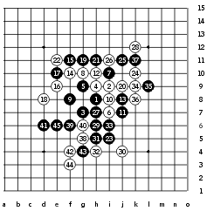
Kawamura - Meritee, 1:0, 45 moves
This game was played in the 6th round of the tournament. It was one of the most crucial games of the tournament, in some way deciding the winner of the tournament, if to speculate so. Interesting coincidence is that in the last World Championship, the top two players also met in the 6th round.
Meritee was the leader of the tournament after the 5th round this time, having won all 5 games. That nice score shaded the capabilities of Ilyin in first 5 rounds, who was following closely and took the leadership soon after that.
So, the 100% leader Meritee versus Kawamura who had 4 points from 5 rounds.
Opening i11 was not a big surprise. Kawamura chose blacks, and Meritee led the game into variant where he thought white has everything under the control, but Kawamura proved fast how wrong his opponent was. The 14th move was very popular at that time. Meritee thought that 24th move will bring success for white based on the conclusion of short and unserious analysis. But for his shock, black had a strong way out - look at the move 41! A key to black win. White was helpless. Move 24 turned out to be a losing move.
This game is a good example of the good preparation and skill of Kawamura.
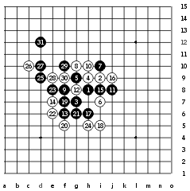
Pogosyan - Nara, 1:0, 31 moves
This game was a surprise for everyone. It had an interesting beginning. There were two games in the first round of the tournament which had the same opening variant - Reims-Karlsson and Pogosyan-Nara.
The new 10th move was used in both games. When Karlsson tried to lead the game to the standard variant with 12-i8, he was surprised - Reims blocked the three from the top! Reims got an advantage in his game quickly and won later. Nara probably did not like the outcome of the 12th move that Karlsson had tried against Reims, and to escape from same destiny, Nara changed the 12th move. But Pogosyan did not even try to balance - he played bravely 13-f6 and it became clear soon that he had just made a winning move. Following moves were white's hopeless attempt to save the game, but in vain. Black won fast.
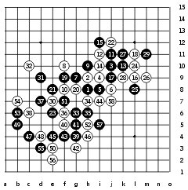
Kawamura - Nara, 0:1, 58 moves
In the 7th round, another duo of games was played - Kawamura-Nara and Ilyin-Gardström.
Two games followed same path until the 30th move after which Kawamura and Ilyin chose different ways to continue the attack. The variant until 19 was quite popular before, especially because black win was not certain there. At least until that time nobody had clearly proved it yet. So, Kawamura had to find the solution across the board, without any knowledge.
However, he was not lucky, the 31st move he chose was a mistake and he lost the chance to win the game. Nara defended calmly, as usually, and did not gamble in defense. Nara just waited passively until black had exhausted its resources and then just made one active move in the whole game after which Kawamura resigned.
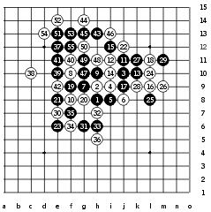
Ilyin - Gardström, 1:0, 55 moves
Ilyin is really a talented player. While Kawamura failed to win against Nara, Ilyin played an excellent game - all his moves were just perfect, as if he was playing according to his home analysis. But the time he spent on moves suggested that he was counting the moves up right across the board. It is amazing how he found the idea of 37th move - a connecting space move. After the 37th move, all the observers realized that Ilyin had made a golden move that was about to bring the win. Move 39 was another beautiful connection. Now white was helpless. Gardström tried to cut the diagonals with 40 but it was too late. A direct black win followed. Nice game!
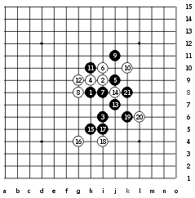
Gardström - Veidemanis, 1:0, 21 moves
Veidemanis was in the top of his renju career at that time. He had just become an European Champion in previous year, and he did very well in the QT before this World Championship. However, despite his skill and experience, he likes to gamble and often uses risky variants against his opponents. The variant up to the 11th move was well known. Veidemanis used gambling 12-g9 instead of traditional 12-g6. According to his idea, he expected black to follow whites with 13-f9.
But Petter Gardström is a high class player - he did not follow such provocations, and concentrated on search of black's possibilities. Finally, Gardström played the active 13, 15 and 17, shocking all the observers of the game, and mostly his opponent Veidemanis who definitely did not expect anything like that.
People approached the table and stared at the position while Veidemanis was thinking, hopelessly. Observers nodded being deeply in thoughts over the game they were watching, wondering, how does Gardström come up with such active and brave moves, which are also so good and effective. A few more moves were made in that game, but they were meaningless. Black got the deserved win!
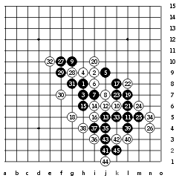
Ilyin - Reims, 1:0, 45 moves
Aldis Reims is one of the best playes in the world. He had been in top 3 in two previous World Championships. People expected not less from him this time. Aldis played well indeed, but one variant that he had prepared for the tournament let him down and he got two bitter losses from Ilyin and Peskov.
In the 5th round he used the gambling i9 opening variant against Ilyin. Moves until 17th were natural. Reims tried 18-g5 in this game. Ilyin played natural moves 19, 21, 23, 25 after which he thought for some time, then chose 27-f10.
Why? I guess Reims asked himself that question. The obervers were wondering, too. Most people made quick conclusion that Reims had successfully defended the right side and therefore Ilyin just jumped to the "new area" to keep attacking. The truth was much deeper than that. In fact, Ilyin's 27th move was not an attack. It was a long term preparation to eliminate the white structure 6_2_20 which was the only piece that was "holding up" the right side's defense system. Reims did not notice that plan. He played in a way that seemed to be the best if it was just about defending the left side attack. By the 32nd move black had gotten the needed control over 6_2_20 line and now the right side attack was ready to go - 33 and 35, and it becomes clear that the planned defense 36-m7 does not work because of 37-i12, eliminating white's VCF threat. Therefore Reims had no choice but block below. And Ilyin proved quickly that he had everything counted and won soon. It took a skill of a master to bring this game to victory, and Ilyin proved that he is a great master!
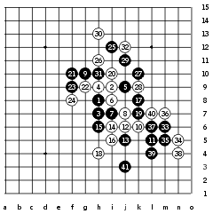
Peskov - Reims, 1:0, 41 moves
This game was played in the last round. Reims once again tried his i9 opening variant, probably, having blamed the loss in game with Ilyin on bad 18th move. So he changed the 18th move to h4. After the 20th move the situation on board was really interesting. Both black and white had enough space and potential to win, only if one got the needed tempo. The following moves were simply a struggle over a tempo. It was clear that losing the tempo would mean the loss of the whole game. Move 21 that Peskov made was the active defense. It was necessary since the passive defense could be disasterous. Moves 22, 23, 24 - further struggle over the tempo. Then, Peskov found the solution for winning the tempo - he spent some of the right and left side forces to eliminate white structures. See the moves 25, 27, 29 and 31. These moves were made for above mentioned reason. Now white had to defend passively already, and that was a bad sign. After the passive 32-j12, black was free to enjoy the right side's power. It took only a few moves to end the game from that point. Excellent lesson of tactics!
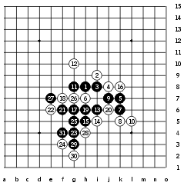
Reims - Meritee, 1:0, 31 moves
Meritee got two losses in this tournament. The loss from Reims was one of them. Meritee tried i6 again that had been one of his favorite openings for years. He tried different fourth moves all the time and left them one by one when they proved to be losing ones. This 4th move was the last one he thought is still playable. However, Reims proved that he has an idea how to win here, using an interesting 11th move! It was really a great move and key to win! Now white was in trouble, to protect the left upper side or right lower side? Either way black wins soon.
After this game, Meritee gave up the dream about i6 and did not use this opening in serious tournaments since that day.
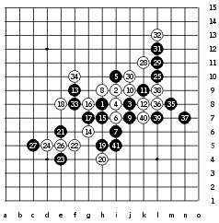
Reims - Veidemanis, 1:0, 41 moves
This game shows a powerful skill of positional style. Reims is really good at such style. He builds the black power slowly, step by step, giving white no chance for survival. After the 17th move it might seem black is not so strong, but in fact, there were lots of "hidden forces". Veidemanis tried to defend the left side, of course with his 18th move. Moves 19 and 20 were natural. Now, the 21st move shows the personality of Reims - there was no real attack power in the left lower corner, but he used his tempo to fill it up with stones, so that this corner could be called "safe", in case he fails to attack in other corners. By the 27th move that corner was full, and all had gone according to Reims' plan. It was not really a dead corner, as you see, later Reims took a good use of the stone 27, playing the 33-f8, which allowed him to create a support line 33_17 to help the right wing attack. Moves 35 and 37 were really beautiful. Reims squeezed the maxium out of the upper force to get some helpful stones for the attack below, and he did it in excellent manner. Therefore, Veidemanis had no escape.
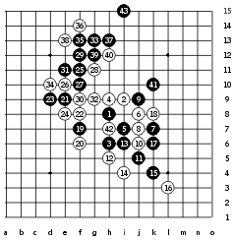
Meritee - Ilyin, 1:0, 43 moves
Ilyin was the tournament leader before this game, having 7.5 points from 8 games, but this game was the turning point - he got 3 straight losses from last 3 rounds and lost his gold medal. Opening i10 with lower 5th move became more popular after Nakamura had introduced the 11-j5 in his game in Meijin Match. By the time of the World Championship, most top players had their own analyses about further moves of the variant, however, the variant from the 14th move that Ilyin made was unclear. Meritee spent lots of time on planning the further attack. It turned out that every black move in this game was absolutely correct, and probably the best way to win. Move 21 was really good invasion to space, followed by 23. So many players would have played the most natural 25-d8, which apparently does not give black win. Meritee was more careful and played the proper 25-f11. After that it became clear that black will have a winning attack. White played the best moves all the time, but still black won the game with beautiful connecting move 41. Ilyin gave up after the 43rd move.
According to Nikolay Mikhailov's famous words, it is the best timing to resign when the opponent makes the winning move on the edge of the board. The confirmation analysis after the game proved that white had no defense already after the 15th move. If 16-h7 then 17-k5, 18-k6, 19-L5, 20-m5, 21-L6.

